Install MySql Workbench
on your PC/Mac at home

This is optional but highly recommended
(so that you do not always have to use CIS lab computers)

Explanation of What MySqlWorkbench Does
Just so that you have a better idea of what MySqlWorkbench does, let’s review some terms.
- Database: collection of related tables. You can think of the database as an encrypted file that holds all the data (from all the related tables) plus metadata (the design of all the tables and all the constraints like Primary Key and Foreign key constraints). Only the database management system can access a database. If any other software could access the database, then there would be no way to completely enforce the database constraints.
- Database Management System: A database management system is software that can access a database. MySql is an example of a database management system (Sql Server and Oracle are two other popular DBMSs). A DBMS is software that runs like a daemon on the database server. If you did not care about having a GUI front end to MySql, you could telnet into cis-linux2, invoke MySql (log in), and type all of your SQL commands (e.g., to create tables, enter data, select data) directly into the MySql command line (black screen) interface
- DBMS GUI: Most types of databases (e.g., Sql Server, Oracle, MySQL) have a Graphical User Interface that makes it easier to so things like design a database, modify data in a database, select data out of a database. In most companies, programmers use a GUI front end to their DBMSs. Since most of these DBMS GUIs are very similar, if you know how to use one, it is easy to learn another. This software may also have the capability to remotely access the DBMS (as in MySqlWorkbench).
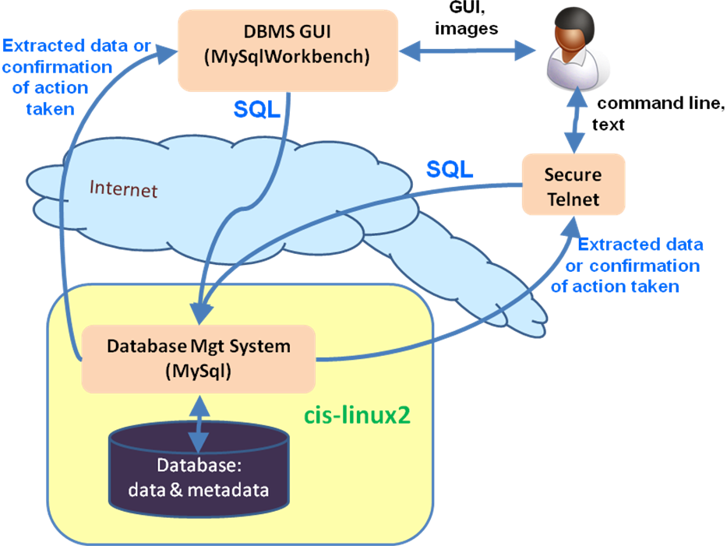

Install MySql Workbench
MySQL Workbench is a free, open source program that provides a nice Graphical User Interface (GUI) to the MySql Database Management System.
Google: “download MySql Workbench”. From here: http://dev.mysql.com/downloads/workbench/
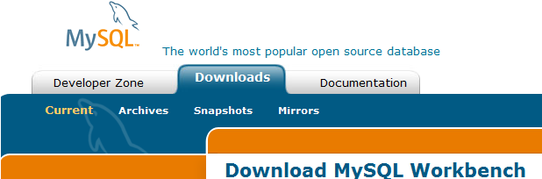

Scroll down, select your O/S and click on one of the download buttons.
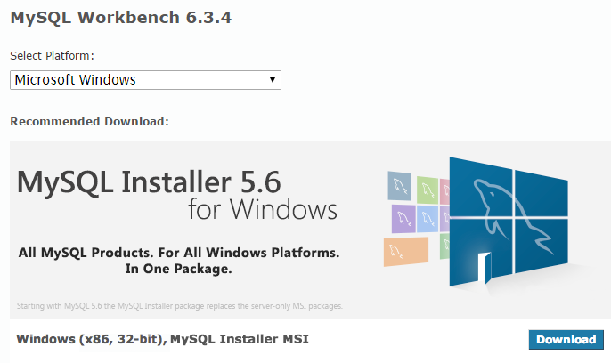

You do not have to login or register. You can just scroll down and click “no thanks”, then save the installation file.

Run the installation file, select all the defaults, and give permission to install (if asked).
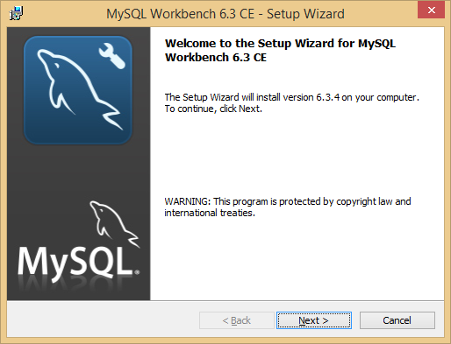

Try running it. The splash screen should look something like this:
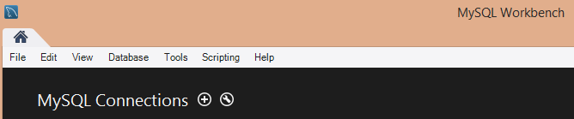

The next thing you will do is click the plus sign to add a connection to your Temple database. This is covered in another document.

